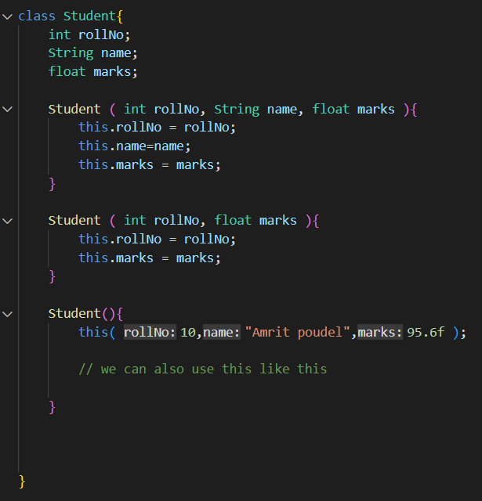

We can also sue this keyword like this in java

But is there any use of this, lets see someday

It can be used to pass the default values, since it’s not good to leave the variables of the objects as empty and null